**INTERNSHIP REPORT**

**ON**

**PYTHON COMPITATIVE CODEING**

**A internship Report is submitted**

**In accordance with requirement of degree of**

**BACHELOR OF TECHNOLOGY**

**IN**

**ELECTRICAL AND ELECTRONICS ENGINEERING**

Submitted by

G.RAKESH REDDY

21KQ1A0293

Under the Mentorship of

**M.SRAVAN KUMAR**



**DEPARTMENT OF ELECTRICAL AND EL ECTRONICS ENGINEERING**

PACE INSTITUTE OF TECNOLOGY AND SCIENCES (AUTONOMOUS)

(Affiliated to Jawaharlal Nehru Technological University Kakinada, Kakinada &

Accredited by NAAC ‘A’ GRADE,An ISO 9001-2015 Certified Institution)

NH-16, Valluru Post , Prakasam District, A.P-523272.

(2024-2025)

**PROJECT TITLE**

**STUMPS STAT ANALYSIS**

**DATE.JUNE 11TH 2024**

**NAME: G.RAKESH REDDY**

**PROJECT DETAILS:**

**ABSTRCT:** This project is about brief explanation ans display about make circket score board . That will be upadate the score board for ball to ball,and update number of wickets.

**Description**:This project about cricket score analysis,we take the input of a set of over.we analysis the stat of players based on runs and wickets,and total score of the match.

Requirements:

Functional requirments

**.over details**:user can take input as number of overs

**.ball to ball:**user can collect ball to ball score data and store

**.score of batter**:user can calculate runs of each player.

**.match details**:user can calculate overall details of score and wickets.

Non-functional requirments:

**Performance**: The system can handle and performance the large number of matchs scores.

**Security**: **Data Integrity**: Ensure that the data is accurate and has not been tampered with.

**Usability**: **User Interface**: The system should have an intuitive and user-friendly interface that caters to both novice and experienced users.

Approach:

**1.Define Objectives**: Determine the specific objectives of the stumps stat analysis, such as understanding player performance trends, predicting match outcomes, or providing strategic insights for teams.

**2**.**Data Collection:** Gather data from reliable sources such as match records, player statistics databases, ball-by-ball commentary, and official cricket boards.

**3. Data Processing and Cleaning:** Implement validation checks to ensure data accuracy and completeness. Remove duplicates, handle missing values, and correct inconsistencies.

**4. Data Analysis**: Compare players, teams, or matches based on various metrics to draw meaningful insights.

**5. Descriptive Analytics**: Use statistical methods to summarize and describe historical data. This includes calculating averages, medians, standard deviations, and other relevant metrics.

**6. Improvement**: stumps stat analysis can provide comprehensive and valuable insights into cricket performances, aiding players, teams, analysts, and fans in understanding and improving the game.

**7.codeing**:To parforme the to create score board of the circket analysis for that we can parforme a coding using python language.

Program or source code:

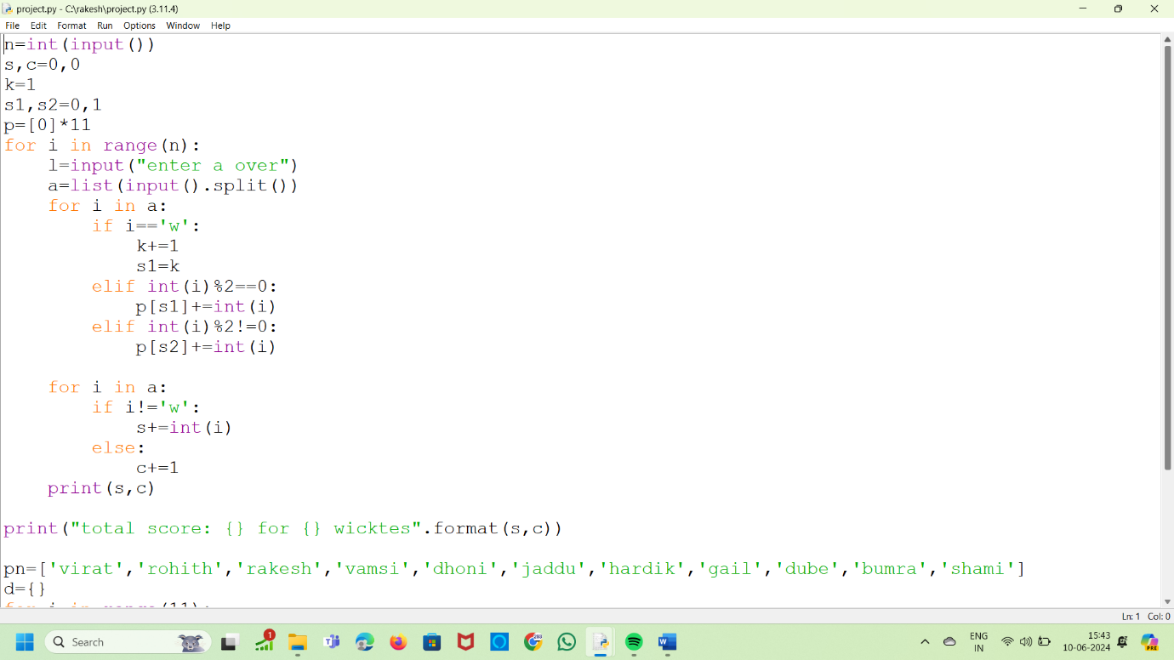

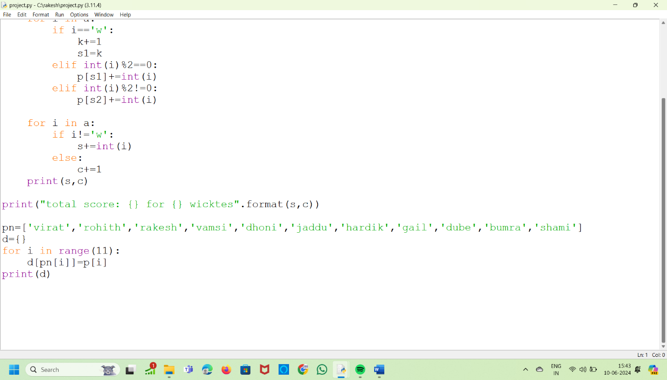

**Output:**

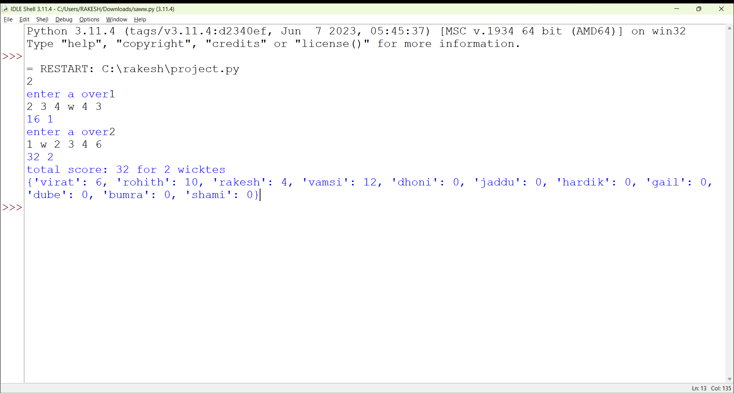

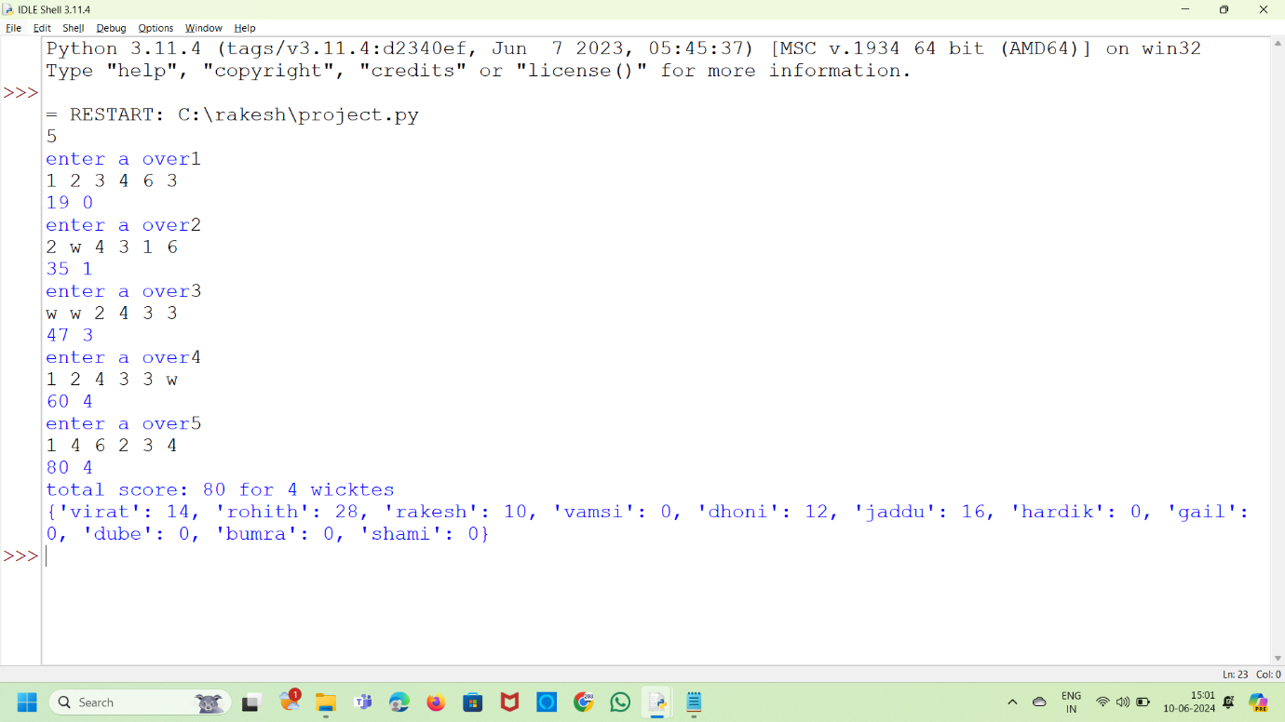

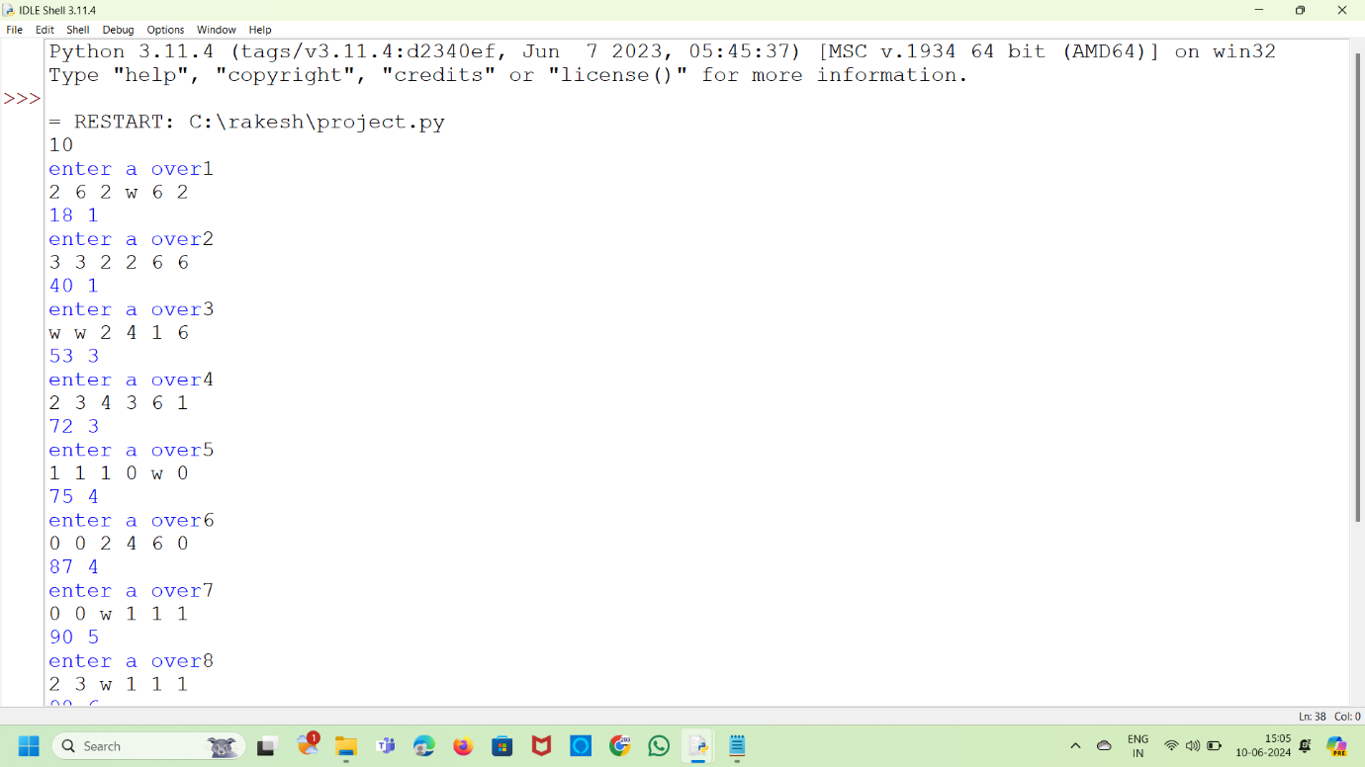

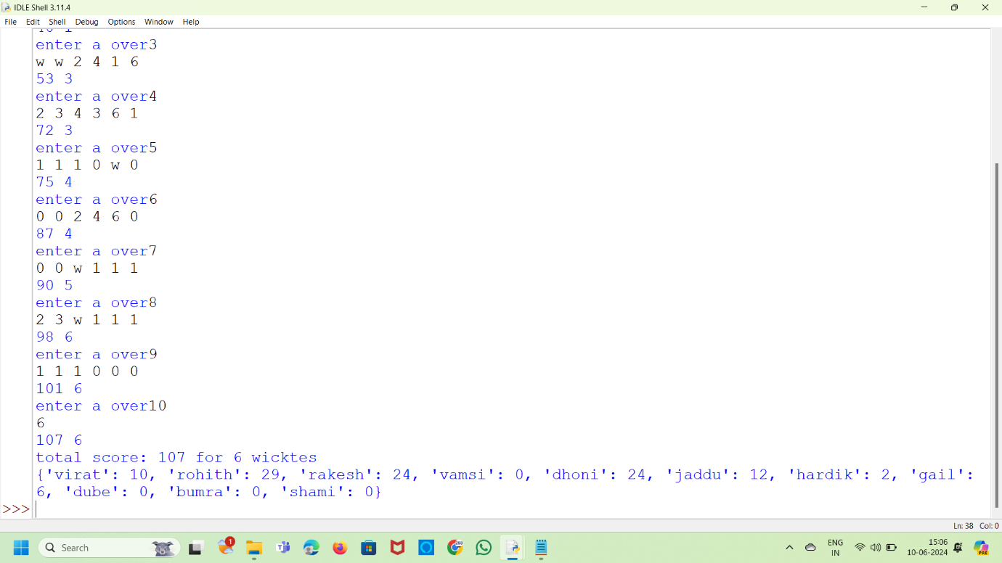

**Explanation:**

For this project of stumps stat analysis ,we can analysis the performance of all players and analysis the score or runs,and wickets.

**1.user interaction**:first user can anlysis the match in that score and wickets.

Players names and individual scores,and analys the total score.

**2.how to approach:** for analys the stat of cricket ,we approach our faculty for their process,and they gauid us how to analys the statics of circket.

In that gaudiness we creat a source or code to make a score board of cricket of the match.

Conclusion:

The conclusion of this project of the stumps stat analysis is to analys the each score of the player.

Analys the total score of the match and total wickets.The main conclusion is to show the all this requirments on the score board.